**REINSURANCE FLOW**

Reinsurance is a transaction whereby a reinsurance company (the “reinsurer”) agrees to indemnify an insurance company (the “reinsured, “cedant” or “primary” company) against all or part of the loss that the latter sustains under a policy or policies that it has issued. For this to achieve, we need to follow the Reinsurance flow to generate a policy.

There are two types of reinsurance:

**Facultative Reinsurance:**

Reinsurance transacted on an individual risk basis. The ceding company has the option to offer an individual risk to the reinsurer and the reinsurer retains the right to accept or reject the risk.

**Treaty Reinsurance:**

A transaction encompassing a block of the ceding company’s book of business. The reinsurer must accept all business included within the terms of the reinsurance contract.

**Key differences between Treaty and Facultative flow is as follows**.

|  |  |
| --- | --- |
| **FACULTATIVE** | **TREATY** |
| Single very large Contract (Calculated per Risk). | All small claims under same class of policies. |
| Has both Proportional and Non – Proportional flow. | Has both Proportional and Non – Proportional flow. |
| Different LOB’s have different starting points. Starting point for property is FCT and for other LOB’s it is IR Destiny system/Modelling System. | Not sure need to check |
| Location Specific. Depending on past records of location a report is generated and premium is calculated accordingly. | Not sure need to check |
| Not sure need to check | Received state is portfolio. |
| Status is changed to quote and layers are created. | Not sure need to check |
| Right to accept/reject each risk on its own merit. | Obligatory acceptance by reinsurer  Of covered business. |
| Not sure need to check | Less costly than per risk insurance. |
| Profit expected by reinsurer in short and long term. Depends primarily on reinsurer’s risk selection process. | Reinsurer’s profit is expected in a long-term relationship but adjusted over extended period of time. |
| For each transaction contract/certificate is created. | Single contract encompasses all subject risks. |
| Individual risk review | No individual scrutiny by reinsurer |

The following diagram will illustrate the Reinsurance policy creation flow for a treaty contract,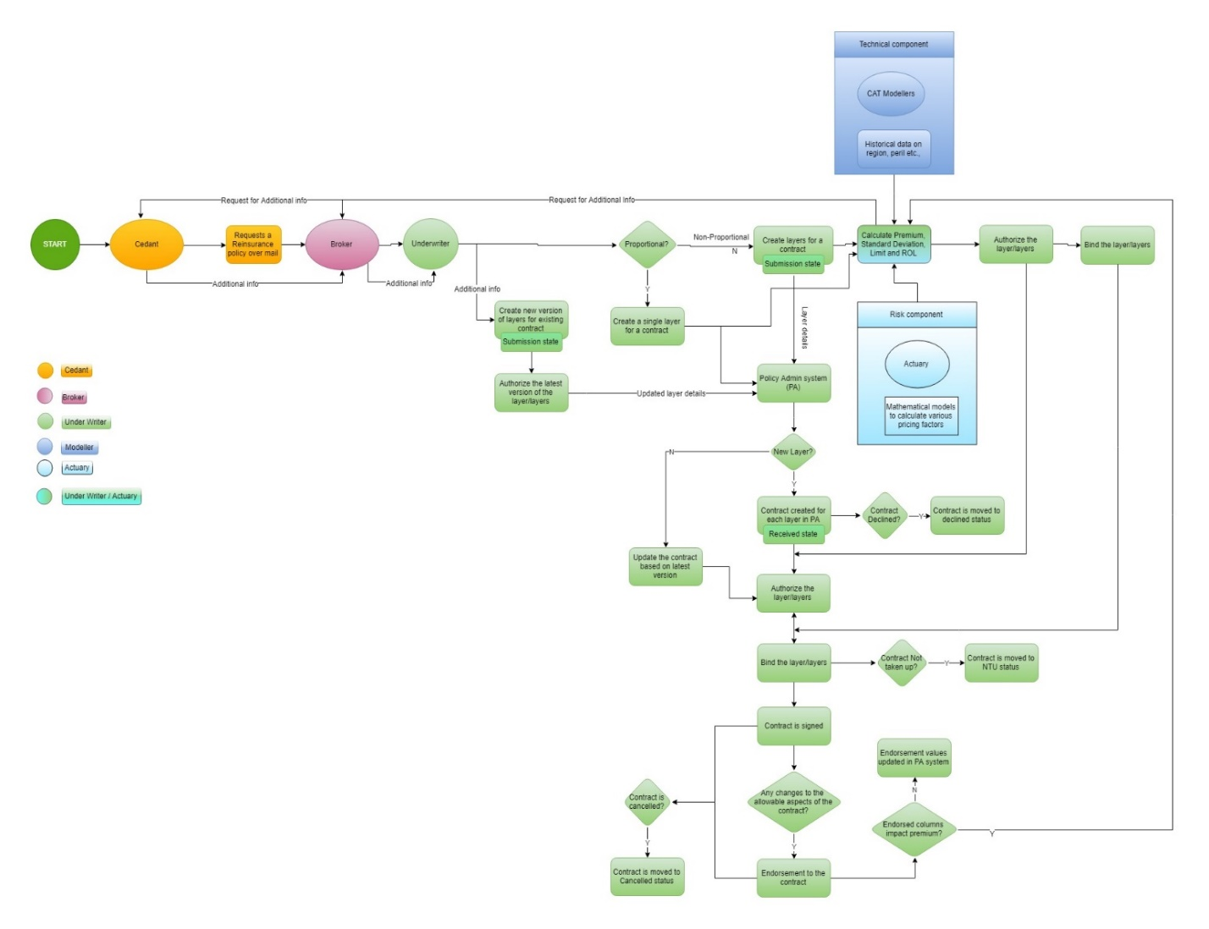

**STEP-1: CEDANT APPROACHING TO BROKER REGARDING REINSURANCE POLICY**

Cedant is an insurance company that requests reinsurance policy from broker over a mail. In some scenarios, broker may need additional information’s about the policy. It may be about property information.

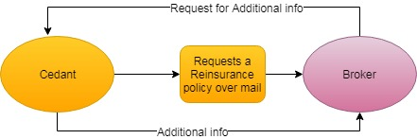

Appendix 1

**STEP-2: BROKER APPROACHING UNDERWRITER**

This reinsurance request is given to underwriter for further analysis. An underwriter can be a business or a person. If he requires any additional information about the policy, he requests this information from the broker.

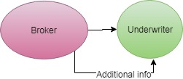

Appendix 2

**STEP-3: UNDERWRITER ACTIVITIES**

Underwriter decides whether the given policy is proportional or non – proportional form of reinsurance and creates layers/policies/contracts accordingly and it will be in Submission State.

**3a**. In proportional contract, underwriter creates a single layer/policy/contract and submits to policy admin system.

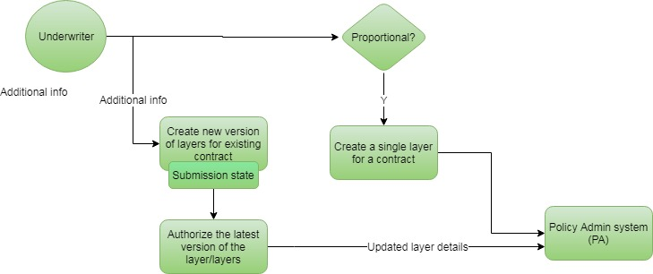

**3b**. In non-proportional contract, underwriter creates multiple layers/policies/contracts and submits to policy admin system.

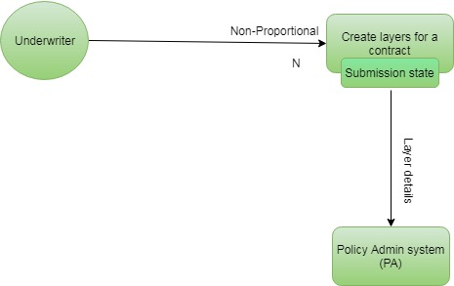

**Appendix 3**

**STEP-4: LAYERS SENT TO POLICY ADMIN SYSTEM (PAS) AND PRICING SYSTEM (PS)**

The newly created layers are sent to Policy admin system (PAS) meanwhile premium calculations take place in Pricing System (PS). Underwriter calculates Premium, Standard Deviation, limit and RDL based on layer detail along with CAT (Catastrophe) modelers (Historical data on region etc. – Technical Component) and actuary (Mathematical models to calculate various pricing factors – Risk Component).

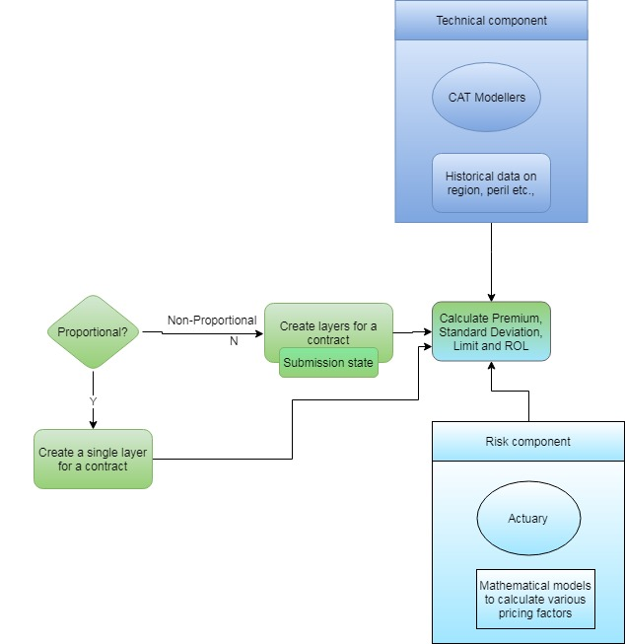

**Appendix 4**

**STEP-5: NEW LAYERS PREMIUM CALCULATION IN PRICING SYSTEM**

In premium calculation, sometimes the cat modelers requires additional information’s from Cedant/Broker via Underwriters, then the Underwriters will creates new version of layers for existing contract and authorize the same. Also the revised layer details will be submitted to policy admin system.

For Premium Calculation, the following contract components are considered:

* Limit
* Deductible
* Share percentage

The underwriters Selects the risk Components for the premium calculation. Maximum of five Risk Components can be chose. After selecting the risk, the underwriter selects the method in which risk are to be calculated based on the selected risk components.

Based upon the input from the under writers, calculations are done in each method by the formulae proposed by the Actuaries and the result from each method is given weightage and they are summed as technical premium.

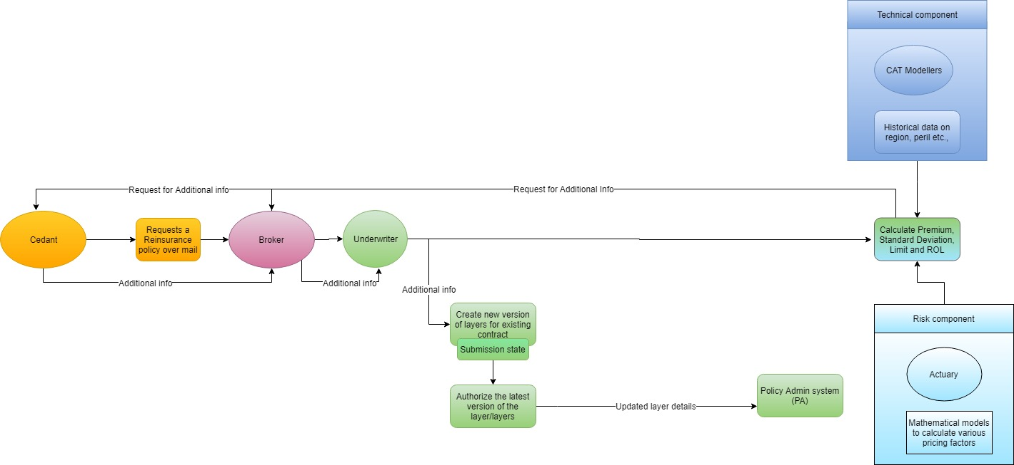

**Appendix 5**

**STEP-6: PA VALIDATE THE LAYERS AND MOVE IT TO RECEIVED STATUS**

Once the newly created layers submitted to Policy Admin System, the PAS creates contract for each new layer.

If the layer is not new and already existing in PAS the corresponding contract will updated based on latest version.

Now the contract is in ‘Received status’ in PAS

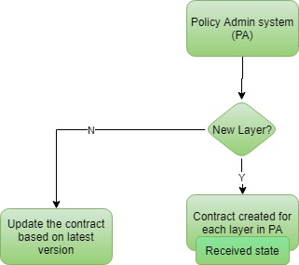

**STEP-7: DECLINING A CONTRACT**

The contracts that are in received status might be declined and moved to declined status in Policy Admin System.

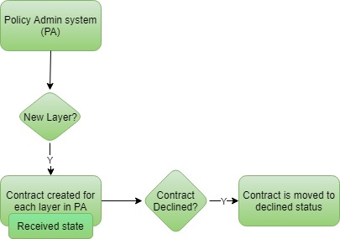

**Appendix 7**

**STEP-8: AUTHORIZING & BINDING THE CONTRACT IN PAS & PS**

In order to move the new/updated contract (which is in received status) to authorize status in Policy Admin System, premium calculation process should have completed for the layer and it has to authorized in pricing system

Once authorized in PAS, the contract has to move to ‘Binding’ status in PAS only after the corresponding layer moves to ‘Binding’ status in Pricing System.

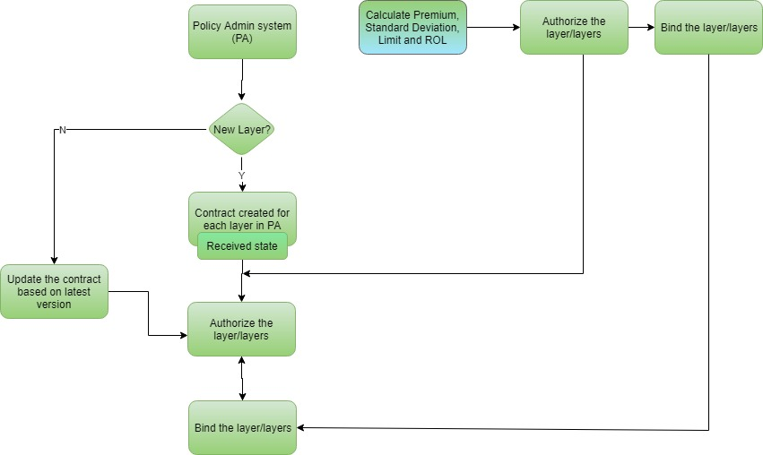

**Appendix 8**

**STEP-9: PA VALIDATES AND SIGN/NTU THE CONTRACT**

Even after moving the contract to authorize and bind, the contract might not be taken up in PA system and it can be moved to NTU status, else the contract gets into ‘Signed status’.

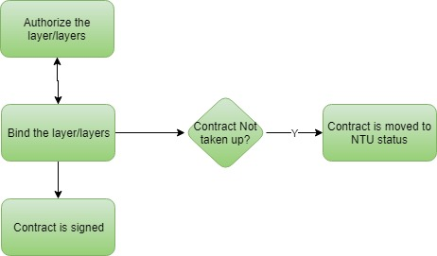

**STEP-10: CANCEL/ENDORSE THE CONTRACT**

Once the contract was ‘Signed’, there is a possibility to cancel/endorse the contract in later point. If the contract cancelled, it will moved to ‘Cancelled Status’ in Policy Admin System.

**STEP-11: PAS VALIDATE CONTRACT CHANGES TO THE ALLOWABLE ASPECTS**

The Cedant wants to endorse the contract. Policy Admin System validate the changes to the allowable aspects of the contract and move it for endorsement.

**STEP-12: PAS VALIDATE THE ENDORSED COLUMNS AND UPDATE PREMIUM**

The Policy Admin System once again validate the endorsed columns will affect the premium or not. If yes, the contract will moved for premium calculation (step-5) to calculate the latest premium and follow the step 5 - 9 again, else the endorsement values updated in system.

**Appendix**

**Appendix 1:**

**Who is Cedent?**

A cedent is a party in an insurance contract who passes financial obligation for certain potential losses to the insurer. In return for bearing a particular risk of loss, the cedent pays an insurance premium.

**Appendix 2:**

**Who is Broker?**

A reinsurance broker is a person who acts as an intermediary between an insurance company and a reinsurance company. Reinsurance brokers work for the insurance company and their job is to acquire reinsurance for it. This can involve negotiating rates and finding the best policies.

**Appendix 3:**

An underwriter is someone who assesses risks for an insurance company. This assessment helps the reinsurance company determine premiums the policyholder should pay based on the risk. The underwriter may act as an actuary, an insurance statistician who analyzes probabilities based on statistics. From these conclusions, insurance rates are calculated.

**(Q14)Difference between policy and contract ?**

**Policy** - Another expression for the insurance contract. A legal document which indicates the terms and conditions on which the contract between the insured and the insurer is based on.

**Contracts:**

Most of the reinsurance contracts that cover more than one policy (treaty).Reinsurance can also be purchased on a per policy basis, in which case it is known as facultative reinsurance. Facultative reinsurance can be written on either a quota share or excess of loss basis. Facultative reinsurance contracts are commonly memorialized in relatively brief contracts known as facultative certificates and often are used for large or unusual risks that do not fit within standard reinsurance treaties due to their exclusions. The term of a facultative agreement coincides with the term of the policy. Facultative reinsurance is usually purchased by the insurance underwriter who underwrote the original insurance policy, whereas treaty reinsurance is typically purchased by a senior executive at the insurance company.

Reinsurance treaties can either be written on a "continuous" or "term" basis

*Continuous Contract*

A reinsurance contract that does not terminate automatically but continues

indefinitely unless one of the parties delivers notice of intent to terminate.

*Term Contract*

A form of reinsurance contract written for a stipulated term (usually one year). The contract automatically expires at the end of the term and renewal must be negotiated.

**(Q21)Do we have Excess of loss in Insurance ?**

In simple terms, an excess of loss public liability insurance policy is a policy used to increase the public liability limit of indemnity to provide additional cover over and above that provided by any primary liability insurance policy.

* Excess of loss public liability insurance policies can be used when the insurer of the primary limit of indemnity is unable to provide a high enough limit of indemnity or is charging an uneconomic premium for cover at a certain level of cover.
* Excess of loss public liability insurance policies are stand alone, additional policies that provide cover for a specified limit of indemnity in excess of the primary limit of indemnity.
* If a very high limit of indemnity is required, there can be a number of excess of loss public liability insurance policies, normally referred to as layers, each providing different limits of indemnity to stacking up to achieve the required total limit.

An excess of loss public liability policy will normally follow the terms and conditions of the primary public liability policy and any underlying layers. However, this is not always the case and additional restrictive conditions can apply to the excess of loss policy that do not apply to the primary policy or underlying lying layers. These additional restrictions can be shown by specific endorsements to the policy or may be contained within the general conditions or exclusions, with asbestos and terrorism exclusions being examples of this.

**What is Proportional Reinsurance?**

With a Proportional Form of Reinsurance Cover, the Insurer and the Reinsurer share the sums insured (Liabilities) in a clearly defined proportion. This proportion (for Quota Share Treaties) is usually stated in the schedule of the treaty agreement. In addition to sharing the sums insured, the premiums and claims are equally shared in the same proportion. There are two main forms of proportional reinsurance - Quota Share and Surplus Share.

To give you a better understanding of this, consider a basic proportional arrangement between Insurer A and Reinsurer Z. Insurer A enters into a treaty agreement with reinsurer Z to buy Reinsurance protection for 40% of the risks it underwrites under its fire business. Under the proportional arrangement, Reinsurer Z will bear 40% of the liabilities (sums insured) for every fire risk. In addition to this, 40% of the premium will be transferred to Z as the cost for the protection. When a loss arises, Z will pay A 40% of the losses incurred. You will notice that the proportion is stated as 40% and applies across the liabilities, premiums and Losses.

**What is Non – Proportional Reinsurance?**

Non-proportional reinsurance focuses on claims, the reinsurer pays a claim if the loss incurred by the primary insurer exceeds a certain agreed amount or level, known as the deductible. The cover granted for a portfolio may be broken into several segments known as layers. The various types of non-proportional treaties differ according to whether the cover applies to individual or to aggregate claims and, in the latter case, depending on the rules used to arrive at the aggregate: excess‐of‐loss cover, aggregate excess‐of‐loss cover, and largest‐claims cover. The premium for a non-proportional treaty is calculated on the basis of risk theory.

Non-proportional reinsurance is an effective way of improving the ratio between the primary insurer's loss burden and premium income, as it passes specifically the peak losses on to the reinsurer.

In Facultative Underwriting depending on LOB, starting point for the flow is decided. For property, starting point is FCT and for other LOB it is IR Destiny system.

**Facultative Clearing Tool :** Clearing process for the location is performed and report is made.Geocoding for location followed by RMS/AIR is performed and latitude and longitude is calculated for the location which helps to prepare the report.

**IR Destiny system :** IR will create a contract followed by Quote, Bind, Issued.

**Appendix 4:**

**(24)Calculation of Risk the Criteria and the tools used how the Risk is Calculated – e.g. Have a Discussion with Pricing team and to add those points also in the Flow Diagram**

For Premium Calculation, the following contract components are considered:

Limit, Deductible, Share percentage

Risk Components:

The underwriters Selects the risk Components for the premium calculation. Maximum of 5 Risk Components can be chose. Below are the available risks for each risk component:

1. Aviation

2. Marine

3. Terrorism

4. Clash

5. Natural Calamity

6. Single risk

7. Severe Connective Storm

8. All Risk

Risk Calculation methods:.

After selecting the risk, the underwriter selects the method in which risk are to be calculated based on the selected risk components. Below are the list of methods available for risk calculation:

1. Experience

2. Exposure

3. Cat Exposure

4. Cat pricing

5. Curve fitting

6. Bordereaux

7. Swing

8. Paretologn

9. Cat burn cost

10 .GULR

11. ROE

12. Other

13. Credibility

14. Fit on RP

**Premium Calculation**:

Based upon the input from the under writers, calculations are done in each method by the formulae proposed by the Actuaries and the result from each method is given weightage and they are summed as technical premium.

**(Q22)Risk Calculation for Additional info?**

Risk calculation is different with respect to Contract creation calculation.

Risks  Calculation

In fire insurance, the physical units of property at risk instead of perils or hazards.

In reinsurance, each insurance company makes its own rules for defining units of hazard or single risks.

The different types of properties or insurable interest, e.g., non-hazardous risks and protected risks.

Risk calculation is based on the risk method chosen in the selected Risk Component.

Different Risk types are available which can be chosen based on the location and other factors such as operational risk, capital risk, liquidity risk etc. Various Risk methods can be chosen among them

Based on the methods chosen, LOSS and standard deviation will be calculated which will impact the calculation of PREMIUM.

Risk analysis are divided into Qualitative and Quantitative Risk Analysis as classified below.

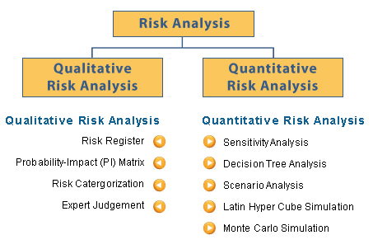

Quantitative Risk Analysis process actions presented below.

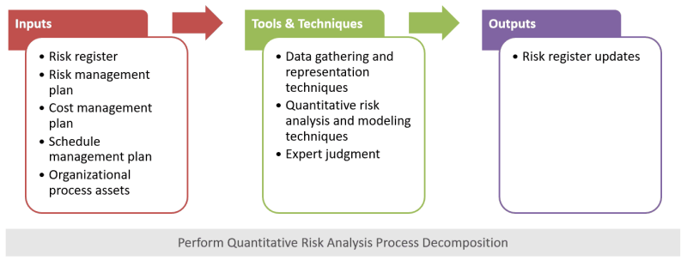

Risk Factors

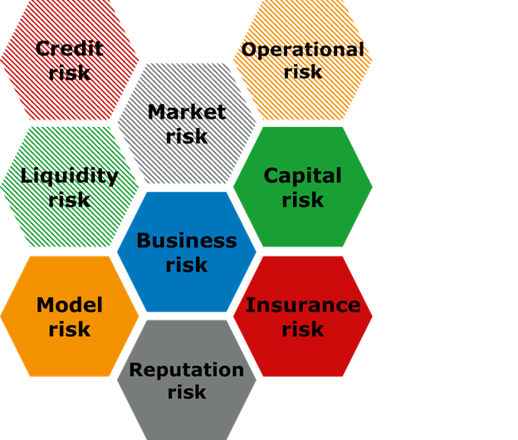

**Appendix 5:**

**(Q23)XCAT -> Pricing Flow Details?**

There are a number of factors to consider when an insurer and reinsurer put a price. Usually, calculations begin with a determination of the cost to the reinsurer of not commuting. This cost defined in a way - of present value of expected future paid losses (using an after-tax discount rate appropriate to the company and line of business. When the Contract is available for loss calculation and CAT modeler would add the YLT , Analysis and generates the PML (Probable maximum Loss) and this PML details would be pulled back by the Underwriter and they will calculate the Premium.

**(Q15)In treaty flow diagram, in update the contract section, again calculation will happen or not ?**

In treaty flow diagram, in update the contract section, again calculation will happen by modifying properties.

Properties such as Limit, Deductible, estimated share and signed share are editable and then contract calculation will be updated in contract.

**Reinstatement**

One solution to running out of reinsurance limits is to insert a clause that automatically or permissively allows the limits to reset once exhausted. This is called reinstatement.

Reinstatement typically has no application to a proportional or quota share reinsurance contract, which typically based on a percentage of sharing premiums and losses between the ceding insurer and the reinsurer. Reinstatements are more common in property reinsurance contracts written on an excess basis, although they do appear in other contexts. In fact, Strain defines reinstatement as:

**The restoration of the reinsurance limit of an excess property treaty to its full amount after payment by the reinsurer of loss as a result of an occurrence.**

**Robert W. Strain, ed., *Reinsurance* (Strain Pub. & Seminars Inc., 1997), Glossary.**

A reinstatement clause allows the per occurrence limit to reset and pick up those additional claims under that same occurrence (of course limited to the new reinstated limit), which otherwise would not be reinsured under that reinsurance contract.

In some property reinsurance contracts, reinstatements are provided for free and can apply as many times as necessary. In other reinsurance contracts, one reinstatement is allowed subject to the ceding insurer paying the reinstatement premium. The number of reinstatements allowed, the cost of those reinstatements, and the manner in which the reinstatement will be applied is all subject to negotiation.

### **What is Reinstatement Clause**

A reinstatement clause is an insurance policy clause that states when coverage terms are reset after the insured files a claim. Reinstatement clauses typically do not reset a policy’s coverage limit, but they do allow the policy to restart coverage for future claims.

### **BREAKING DOWN Reinstatement Clause**

A reinstatement clause states when coverage terms are reset after the insured files a claim. Individuals and businesses purchase insurance policies to cover themselves from damages or losses caused by specific perils, such as fires and floods. Coverages are triggered when the peril being insured against occurs, at which point the insured can file a claim to receive money to cover damages.

The amount that the insured can recoup from the insurer is set at a maximum amount, called the coverage limit. This limit may be set on a per occurrence, per risk basis, or aggregate loss basis.

Insurance companies that are still processing a claim may want to limit any further coverage for an insured peril until the claim is paid out. In order to be covered from future perils while an existing claim is still active, the insured would have to make sure that the policy is reset and the coverage renewed. This is done through a reinstatement clause.

Reinstatement clauses indicate the point at which coverage restarts. The restart may be triggered by a claim being filed or by a claim being paid out by the insurer. Additionally, the clause will indicate whether the coverage limit is reset (in per occurrence contracts) or whether the same limit applies (in aggregate loss contracts).

The ability to reinstate a policy is not guaranteed by law, so the availability of a reinstatement clause may differ between insurance providers and policies. The process and requirements for a reinstatement may also differ from policy to policy. It largely depends on how much time has elapsed since an insurance policy lapsed, the company, and the product type being reinstated. It might be less expensive to get a new insurance policy than to reinstate an old policy.

### **Reinstatement Clause in Action**

For example, a business purchases a property insurance policy, and the business operates in an area that occasionally has floods, but the frequency of the floods is typically low. Over the course of the summer, the area receives more rain than expected, and the business is damaged by floodwaters. After the business filed a claim for this damage – but before the claim was settled – another storm passed through the area and caused additional damage. Because the policy had a reinstatement clause that reset coverage after the first claim was filed, the policyholder was able to make a subsequent claim following this second, separate flood.

**Appendix 7:**

**(Q20)When contract will be declined ? what scenario?**

NTU/Decline/Cancel - All 3 are involved in the retreat of taking up a contract- rejecting, cancelling or not taking up the contract.

**Decline**

* Contract will be declined.
* Decline operation can be done once the contract is in received or quoting state.
* Can be authorized, bound or moved to not taken state from Declined and so the contract can be proceeded further.

**Cancel**

* Contract will be cancelled.
* Cannot be reinstated (taken up again) but can only be endorsed.
* Cancel operation can be done once the contract is in signed contract or signed slip state.

**NTU**

* Contract won’t be taken up.
* Not taken operation can be done once the contract is in received, quoting, authorized or declined state.
* Can be moved to authorized state from NTU and so the contract can be proceeded further.

If a contract is moved to cancelled state it is fixed and the contract cannot be proceeded further. If it is in NTU/Declined state, state can be changed and policy can be taken up by signing the contract.

A contract is moved to these states due to various reasons. Some of them are:

Lack of info to quote, XL's pricing too competitive, terrorism, XL's security, terms & conditions, etc.

**Appendix 8:**

**(Q16)Who authorize the layer?**

An Underwriter with full access to the contract's company.

**Any limitation and criteria a authorize the layer?**

* A destiny contract should be created and linked to that layer.
* The layer's contract should be AUTHORIZED in Xlerate legacy app.
* LIMIT & AUTHORIZED PERCENTAGE are mandated to AUTHORIZE a Layer
* Should have a Valid Cedent company, Cedent location & Broker company